USGS Core Sampling in the Water Sinks, Burnsville Cove, VA (ca. 2009)

Philip C. Lucas supplied the following information in a private communication August 4, 2020 to the BCCS webmaster. Work is underway to find a link to the reported GSA presentation abstract.

In 2009, the U.S. Geological Survey (USGS) collected several ~65-foot long cores on the Lucas property on RT 609 (Pancake Field at the Water Sinks) in order to learn more about the region’s past climate. Several results were recently presented at the Geological Society of America Southeastern Sectional Meeting in Columbia, SC.
By extracting pollen from the sediment in the cores and using radiocarbon dating on carbon in the sediment, USGS scientists were able to reconstruct past vegetation in the area and make inferences about climatic conditions from approximately 26,000 years ago. Pollen was not preserved in the entire core, only in sections that comprised clay or finely laminated clay. These clay/ laminated clay sections indicate that a lake occupied core site some time during the Last Glacial Maximum. Changes in the sediment type in the core (changing from clay to sand or gravel) shows that there were times when there was no lake present at the Lucas property. Unfortunately, there was no other material suitable for radiocarbon dating in these intervals to give an idea when the lake was not present or the brief intervals when the lake returned. The pollen trapped in these lake sediments show that spruce, fir, and jack pine were the dominant tree types. This assemblage of trees is indicative of boreal-like conditions, or at least much colder temperatures in the region than at present. For example, jack pine is only found in a single county of West Virginia and is more abundant in northern US and Canada. Part of a larger project funded by the USGS Climate and Land Use Change Mission Area R&D Program, the next step is to tie these findings to other records in the region in order to understand broader climate patterns over the last 26,000 years.
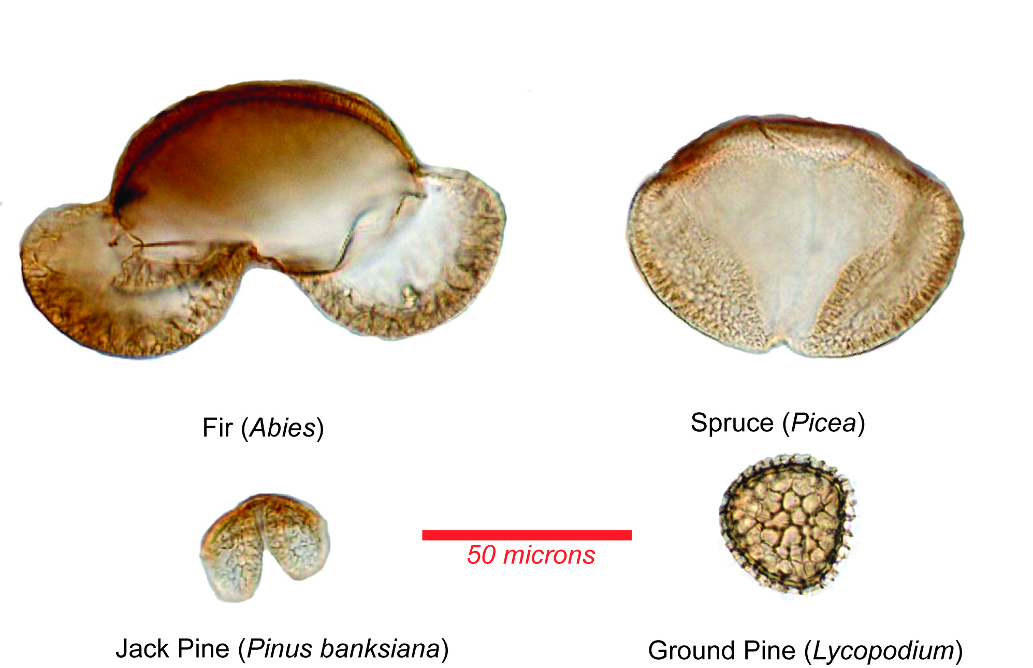
Photo caption: Pollen extracted from core section deposited at Lucas property during Last Glacial Maximum. Photo credit: Christopher Bernhardt

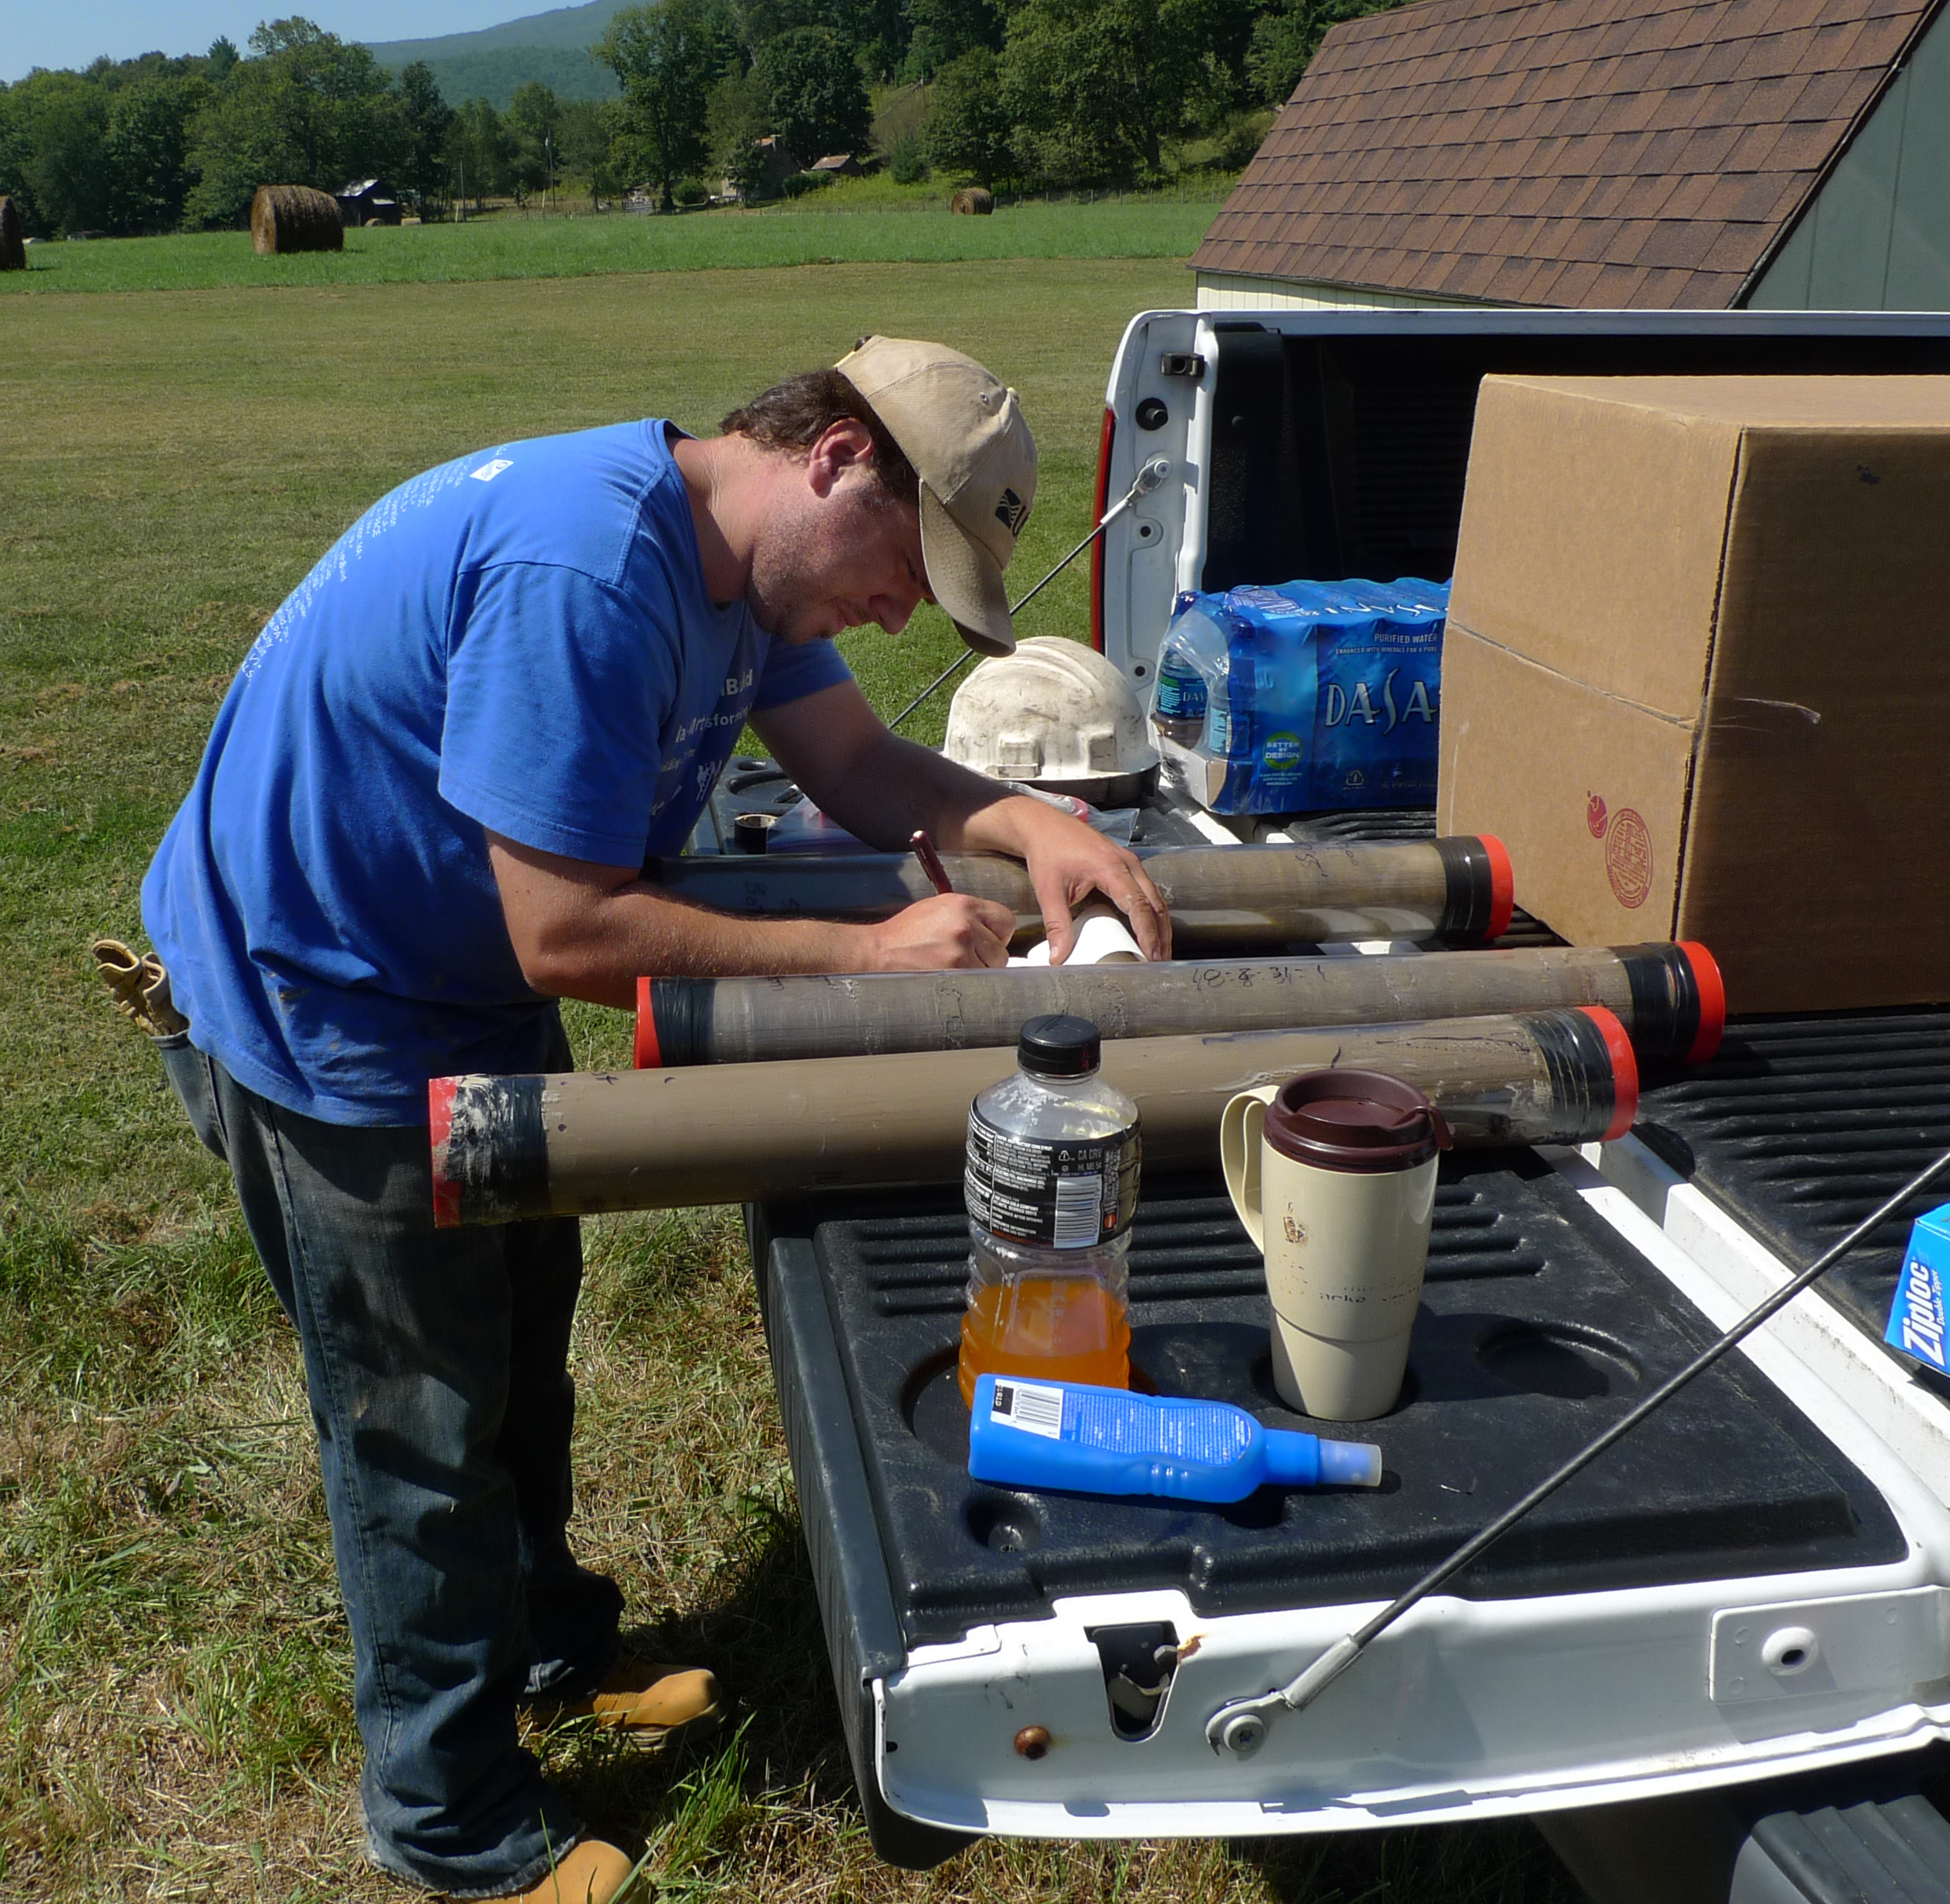
Photo caption: Christopher Bernhardt labeling cores: Photo credit; Phil Lucas

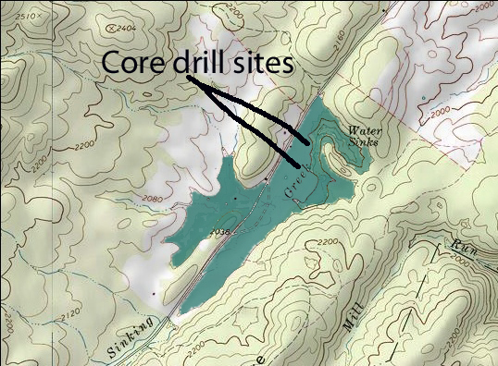
Caption of ancient lake illustration: An ancient lake, approximately 1 mile long and a half mile wide, once filled a large sinkhole depression called a blind valley. The bottom of the lake bed accumulated sediments creating what is now called the Pancake Fields. A deep sink, called the Water Sinks, in the downstream end of the depression was the drain which eventually emptied the lake. Illustration by Phil Lucas

